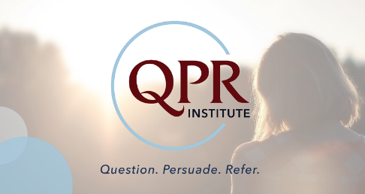

*Prevent Suicide…*

*Become a QPR Gatekeeper*

\_\_\_\_\_\_\_\_\_\_\_\_\_\_\_\_\_\_\_\_\_\_\_\_\_\_\_\_\_\_\_\_\_\_\_\_\_\_\_\_\_\_\_\_\_\_\_\_\_\_\_\_\_\_\_\_\_\_\_\_\_\_

2019 COMMUNITY COURSE OFFERINGS

**A Suicide Prevention Gatekeeper** is a person trained to recognize a suicide crisis and because of their training, knows how and where to find help. QPR (Question, Persuade, Refer) offers hope through positive action.

* QPR Gatekeeper training is FREE and takes just 90 minutes
* Information is easy to understand
* Receive QPR booklet with warning signs, methods to encourage help
* Receive Community Resources

|  |  |  |
| --- | --- | --- |
| Date | Time | Location |
| March 5, 2019 | 2:00 - 3:30 PM | UM Upper Chesapeake Health, Bel Air/Harford Conference Room – 520 Upper Chesapeake Drive, Bel Air |
| May 14, 2019 | 2:30 – 4:00 PM | Fallston Public Library - 1461 Fallston Road (Route 152) |
| September 19, 2019 | 6:00 – 7:30 PM | Jarrettsville Public Library – 3722 Norrisville Road |
| October 2, 2019 | 2:00 – 3:30 PM | UM Upper Chesapeake Health, Bel Air/Harford Conference Room – 520 Upper Chesapeake Drive, Bel Air |

QPR is a national program that teaches you how to identify and help people who are thinking about suicide. Join us to learn how to understand and respond to the clues of suicide.

REGISTRATION

To register, please call: University of Maryland Upper Chesapeake Health HealthLink – Linda Addington or Kristina Hoagland @ 1-800- 515-0044. The course is FREE OF CHARGE!

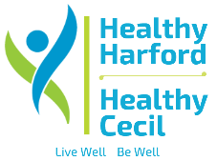PARTNERS/INSTRUCTORS

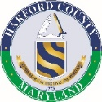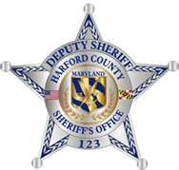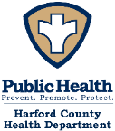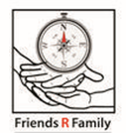

[Old icon /_layouts/images/uch.jpg](http://uchintranet.uchs.org/)

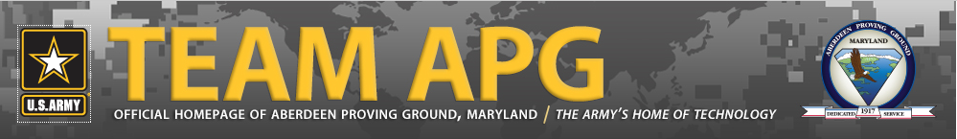

**It’s easy to host a free QPR Gatekeeper training at your place of employment, church, community group or school. For more information, contact us @ 1-800-515-0044**