HR Community Advisory Board
Minutes 1/12/22
In Person/Virtual via Google Meet

In Attendance: Zach K, Jack L, Greg F, Kelci R, Chris G, Sandi G, Jason B, Jessica O, Austin T, Jack K, Linda B, Clay A, Jon F, Katie L, Justin M, Karen F, Sydney S, Tara L

1. Introductions
2. HCHD Updates:
- MDH is still dealing with the fallout from a cyber-attack that has impacted some local health departments, including HCHD
- Omicron is becoming the dominant strain of Covid in Maryland
- Please do not go to Hospitals for testing. The hospitals are getting overcrowded and waits are going to be 8-12 hrs +.
- If you have Covid symptoms, look for a testing site or stay home.
3. Drug Checking (see attached slides)
- Project RAD - Rapid Analysis of Drugs project
  - A way to understand the drugs participants are using in MD
  - A tool to provide data about new and potentially dangerous
adulterants and formulations in the current drug supply
  - For harm reductionists to share with their participants so they can
make informed decisions regarding their drug use
- Paraphernalia is obtained anonymously and tested
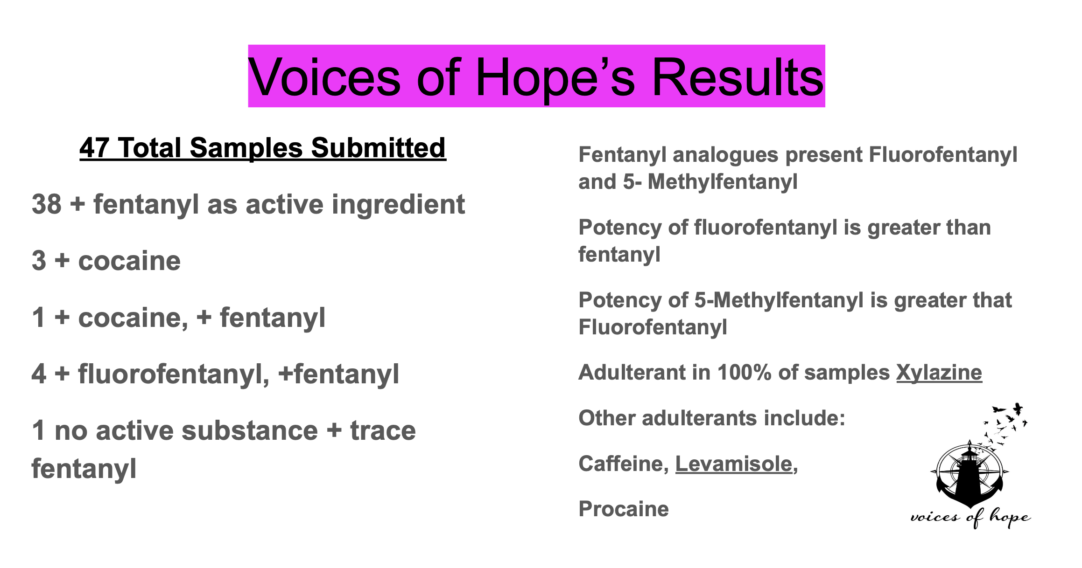
- Results:
4. Workgroup/Organizational/Open Discussion:
- Need group for recovery house owners/operators started by ACR. Please reach out to Clay at ACR or acrhelps@gmail.com for questions and details.
5. Announcements

Our next meeting will be on Wednesday February 9, 2022 @ 6:00 PM.

