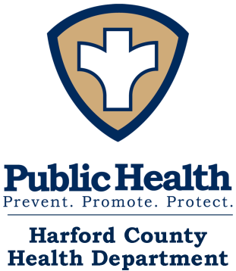
Contact Person: Symone Miller, CSP
Program Supervisor
410-942-7903
Today’s Date
________________________
Harford County Health Department
Office of Lead & Asthma Prevention
Your child may be eligible for the Harford County Health Department Lead and Asthma Program
If they:
- Are a Harford County Resident under the age of 19
- Enrolled in or eligible for Medicaid
- Have a Blood Lead Level of 3.5 mcg/dl and above
- Have a diagnosis of Moderate to Severe Asthma

Child’s Name: __________________________Birthdate: ____________Age:_____________

Parent/Guardian’s Name: _______________________________________________________

Parent/Guardian’s Phone Number:________________________________________________

Email address: ________________________________________________________________

Address/Street:_________________________Town:__________________ZipCode:_________

MA#_________________________________
If you are interested call Symone Miller, Program Supervisor at 410-942-7903 or email her at symone.miller@maryland.gov.
10.31.23

